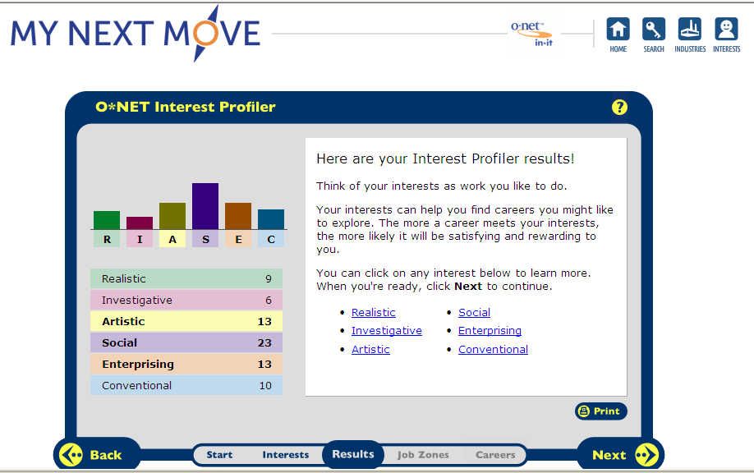
Social- This is also accurate because, I like to deal with people and help them out. I like dealing with kids. I love to help them out and take care of them.
Artistic- This is accurate because, I like listening to music. I also love to dance and dancing in general. I generally like this topic.
Enterprising- I do not think this is accurate because, I do not agree with it. I don’t necessarily like the things that go along with this topic. I don’t think it fits my personality either.
- Early Childhood Associate
- Counselor
- Musical Director
- Designer
- Therapist
- Nurse Aid
- Home Health

Early Childhood Associate:
HR1: The definition is: providing early childhood care and education with their teaching strategies.
HR2: Pre-school teachers, teacher’s assistant, teacher’s special education.
HR3: You should be organized, dependable, patient with children.
HR4: You must have the ability to communicate, inspire, have trust, and to motivate students.
HR5: Planning, a curriculum that covers numerous areas of a child’s development.
RC1:Pre-school teacher’s wages were $23,870 in May 2008…
RC2: Employment of preschool teachers is expected to grow by 19 percent from 2008 to 2018
RC3: Childcare workers and teacher assistants are jobs that would hire in this career field.
ISC1: The working environment is in a class room, with younger children.
ISC2: Most teachers a part of a union.
ISC3: There is a chance to get promoted, if you move up in higher grades. Higher grades get paid more.

--------Counselor:
HR1: The definition is: they assist students; they help with their academic career, etc.
HR2: Psychologists, Social Worker, Registered Nurses, Occupational Therapists.
HR3: You should have a strong desire to help people, respect, trust, confidence.
HR4: A master’s degree is usually required; they must follow the code of ethics associated with their respective certifications and licenses.
HR5: Being able to help student’s problems from dealing with issues from drug and alcohol abuse to death and suicide.
RC1: Median wages rage from $30,000.00 to $60,000.00
RC2:
RC3:

Music Director:
HR1: They conduct groups in instrumental or vocal performances. They also, play instruments, sing, compose /arrange music.
HR2: Related Occupations: producers, singers, directors, dancers, choreographers.
HR3: You have to be creative, music talent, good stage presence.
HR4: Musicians need extensive training and practice. They must know a lot about music styles.
HR5: you need to know how to direct, plan ahead, having talent with music
RC1: Median annual wages of salaried music directors and composers were $41,270 in May 2008.
RC2: From 2008-2018 a musical director, composers, etc, will grow 10%
RC3: Actors, producers, directors, dancers, choreographers would be hired in this career field.
ISC1: Working environment: is working with students and teaching them new things and choreographing
ISC2: No this career is not part of collective bargaining units.
ISC3: You can move up in this field. Such as coming from being a musician to a music teacher.

Designer
HR1: The definition of a designer is, creating new things by hand or computer.
HR2: fashion designers, drafters, computer software engineers, desktop publishers are some relating occupations.
HR3: You have to be creative, know how to communicate, and having problem solving skills.
HR4: you would need a bachelor’s degree in graphic design, need to communicate ideas visually, verbally, and in writing.
HR5: problem solving skills are important and being familiar with computer graphics and software.
RC1: Median wage 42,400.
RC2: it will increase and grow by 13%.
RC3: Artists, Related workers is related in this field.
ISC1: The work environment is working in own offices, working regular hours, adjust work schedule according to clients.
ISC2: No, Designers are not part of bargaining unions
ISC3: Some designers leave this field and become teachers in design schools.

Therapist
Hr1: A therapist is someone who helps individuals with problems mentally physically, emotionally condition.
HR2: Related Occupations: Athletic trainers, Speech – Language pathologists.
HR3: wanting to help people, performing tasks in living.
Hr4: The education and training you need is, science courses, knowing how to practice therapy, etc. master’s Degree is needed
HR5: you need to know how to deal with patients who are physically demanding.
RC1: This occupation pays about $77,630
RC2: 30% is the projected growth.
RC3: school nurses, doctor’s offices.
ISC1: the work environment: hospitals, clinics, private offices.
ISC2:
ISC3: Therapists are expected to continue education courses and workshops.

Nurse Aid
HR1: They help care for physically, mentally, injured, disabled.
HR2: Medical assistants, nurses, child care working are some related occupations.
HR3: They should want to care for people who need their help, friendly.
HR4: Personal care skills must be good in health.
HR5: Having to face heavy workloads.
RC1: Median hourly wages of nursing aides, orderlies, and attendants were $11.46 in May 2008.
RC2: From 2008-2018 there is an 18% growth.
RC3: School nurses, doctors assistants.
ISC1: Nurse Aid’s have to deal with heavy workloads,
ISC2: Nurse Aides also have to go against back injury because you have to be lifting patients the proper way.
ISC3: Advancement is limited.

Home Health
HR1: care for people who need assistant.
HR2: radiation therapist, registered nurses, nurse aide
HR3: They have to support their clients.
HR4: Having to be able to follow detailed instructions.
RC1: Median hourly wages: $7.94
RC2: Growth in this career from 2008-2018 is 48%
RC3: Child Care workers would hire someone in this field, also physical therapists. Any job with helping other people.
ISC1: Being involved with Home Health is very demanding.

Careers:
Early Childhood Associate, Therapist, Counselor
I picked each of these careers because, I love to help people who would need it. I also love being around little kids. Two of the careers I’d only need to get a bachelors degree and the other, I’d need to get a masters degree. That’s not being in school long, for doing something I’d enjoy. The income is a good amount of money to be getting paid. I’d rather be working in early childhood because I want to be around children more than anything.

